**ATTIQA REHMAN**

**FA24-BBA-113**

**SECTION B**

**PROGRAM 1**

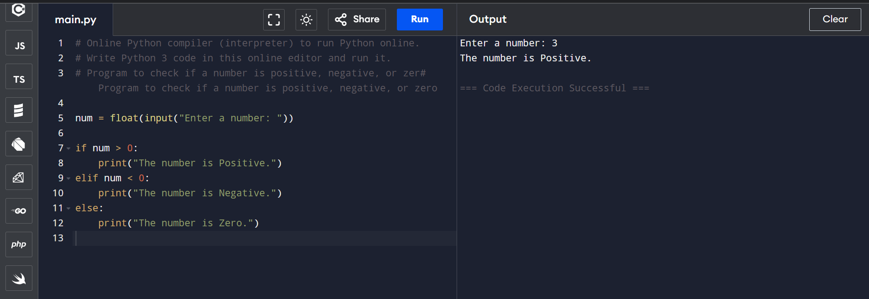

**PROGRAM 2**

**PROGRAM 3**

**PROGRAM 4**

**ACTIVITY 1**

**Weekend Getaway to Murree – Computational Thinking**

**Q.1 Decomposition (Break into tasks)**

* Pre-trip: Budget, transport, hotel, packing
* Travel: Departure, route, fuel/snacks
* On-trip: Sightseeing, food, shopping
* Post-trip: Return, expenses, unpack

**Q.2 Pattern Recognition (Past experiences)**

* Early start avoids traffic
* Warm clothes always needed
* Weekends = crowded
* Advance booking saves time & stress
* Extra costs → mostly food/shopping

**Q.3 Abstraction (Essential elements)**

* Budget
* Transport & accommodation
* Weather & packing
* Food & safety
* Sightseeing/activities

**Q.4 Algorithm Design (Step-by-step plan)**

1. Fix budget & dates
2. Book transport + hotel
3. Check weather & pack essentials
4. Day 1: Depart early → Hotel check-in → Mall Road & Kashmir Point
5. Day 2: Breakfast → Patriata/ Ayubia → Lunch → Return by evening
6. Post-trip: Expenses, unpack, rest